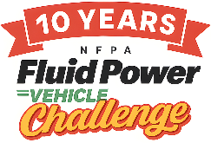
2026 Fluid Power Vehicle Challenge Final Competition Awards
Cedar Rapids, IA

Grand Champion
1st Place – University of Cincinnati
2nd Place – Iowa State University
3rd Place – Oakland University

The following teams won cash prizes for exemplary performance.

Presentation Award  Iowa State University | Best Use of Electronics, Sponsored by IFP Motion Solutions Inc.  Oakland University
Best Use of Pneumatics, Sponsored by IMI  South Dakota State University | Judges’ Choice – Teamwork  University of Illinois Urbana-Champaign
Judges’ Choice - Design  Iowa State University | Judges’ Choice – Innovation  SUNY Polytechnic Institute
Judges’ Choice – Workmanship  South Dakota State University | Exemplary Performance: Efficiency Race  1st: University of Cincinnati  2nd: Western Michigan University  3rd: Oakland University
Judges’ Choice – Spirit  Colorado School of Mines  University of Cincinnati | Exemplary Performance: Endurance Race  1st: University of Cincinnati  2nd: Murray State University  3rd: Western Michigan University
Exemplary Performance: Sprint Race
1st: Iowa State University
2nd: Oakland University
3rd: Murray State University

