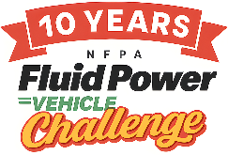

2026 Fluid Power Vehicle Challenge Final Competition Awards
Rockford, IL
Grand Champion
1st Place – Cleveland State University
2nd Place – Loyola Marymount University
3rd Place – Texas A&M University

The following teams won cash prizes for exemplary performance.

Presentation Award  Northern Illinois University | Best Use of Electronics, Sponsored by IFP Motion Solutions Inc.  Northern Illinois University
Best Use of Pneumatics, Sponsored by IMI  Texas A&M University | Judges’ Choice – Safety  Milwaukee School of Engineering
Judges’ Choice - Design  Texas A&M University | Judges’ Choice – Teamwork  Minnesota State University - Mankato
Judges’ Choice – Workmanship  Northern Illinois University | Exemplary Performance: Endurance Race  1st: Cleveland State University  2nd: Loyola Marymount University  3rd: Texas A&M University
Exemplary Performance: Sprint Race  1st: Cleveland State University  2nd: Northern Illinois University  3rd: Loyola Marymount University | Honorable Mentions  Bucknell University  University of California-Irvine  Purdue University - Northwest
Exemplary Performance: Efficiency Race
1st: Purdue University
2nd: Loyola Marymount University
3rd: Cleveland State University

