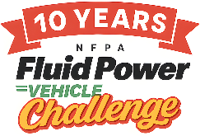
2026 Fluid Power Vehicle Challenge Final Competition Awards
Sarasota, FL

Grand Champion
1st Place – University of Louisiana at Lafayette
2nd Place – FAMU-FSU College of Engineering
3rd Place – Kennesaw State University

The following teams won cash prizes for exemplary performance.

Presentation Award  University of Utah | Best Use of Electronics, Sponsored by IFP Motion Solutions Inc.  University of Alabama at Birmingham
Best Use of Pneumatics, Sponsored by IMI  University of Utah | Judges’ Choice – Perseverance  Tie: University of Utah and Tennessee State University
Judges’ Choice - Design  California Polytechnic | Judges’ Choice – Sportsmanship  North Carolina A&T
Judges’ Choice – Workmanship  Drexel University | Exemplary Performance: Efficiency Race  1st: FAMU-FSU College of Engineering  2nd: University of Louisiana at Lafayette  3rd: California Polytechnic
Exemplary Performance: Sprint Race  1st: Kennesaw State University  2nd: FAMU-FSU College of Engineering  3rd: University of Utah | Exemplary Performance: Endurance Race  1st: California Polytechnic  2nd: University of Louisiana at Lafayette  3rd: Kennesaw State University

