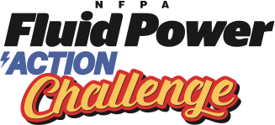
Sign-Up Form

The NFPA Fluid Power Action Challenge is a competition that challenges middle and high school students to solve an engineering problem using fluid power technology.

Complete and return this form to reserve your spot at the following event:

<insert location>
<insert address>
<insert address>
<insert city, state>

Workshop day: <insert date & time>
Challenge day: <insert date & time>

Participating schools provide:

- A team, or multiple teams, of four students (mixed teams are recommended)
- A registration fee of <insert your registration amount> per team
- Transportation for your team to the pre-competition workshop and full day competition

Students acquire numerous skills throughout the competition and are exposed to careers that involve fluid power and other technologies. Teachers are given support and resources for science and technology curriculum.

I would like to participate in the NFPA Fluid Power Action Challenge!

Teacher’s Name:
Name of School:
Address:
# of Teams: | Telephone #:
E-mail:

Return this form with check made payable to: <insert your organization name>
<insert address>
<insert address>
Return by: <insert deadline date>

